Day38 - Task19 - AWS SQS, AWS MQ, AWS Secrets Manager

Amazon Simple Queue Service
To create and test an Amazon SQS Standard Queue and understand how a producer sends messages to the queue and a consumer receives and deletes them.

Step 1: Open Amazon SQS & Create an SQS Queue
- Open Amazon Simple Queue Service.
- In the SQS console, select Queues.
- Click Create queue.
- Select: Type: Standard
- Enter a queue name
Step 2: Configure the Queue

Visibility timeout: 30 sec
This controls how long a received message remains hidden from other consumers while it is being processed.

Message retention period: default
This determines how long SQS retains a message if it hasn't been deleted.

Encryption: Enabled encryption

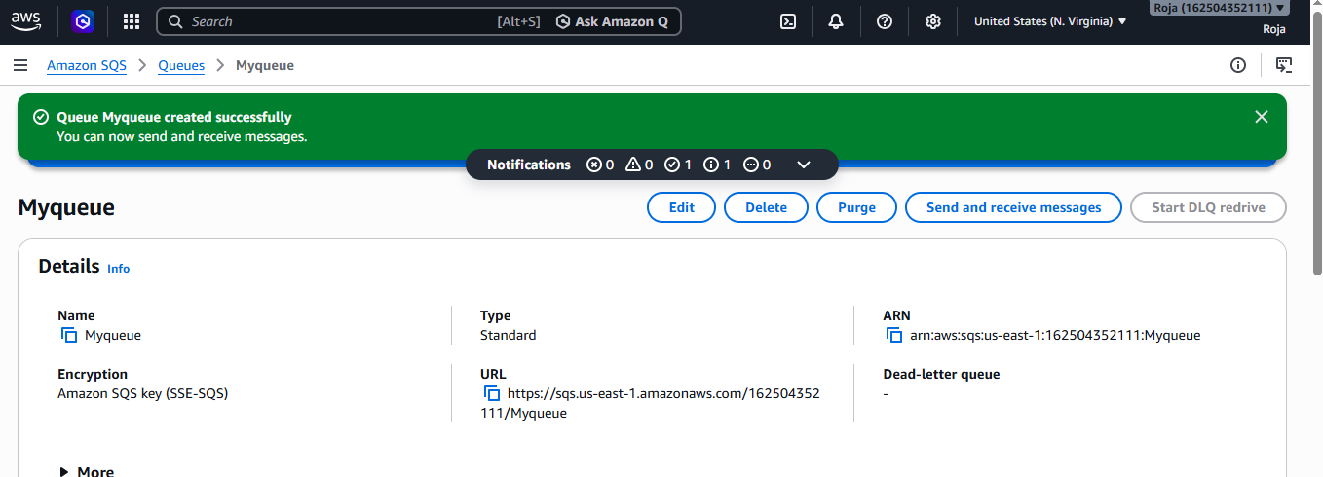

Step 3: Send a Message
Open your queue: Myqueue
Then select:
Send and receive messages
Under Message body, enter something like:
Hello from AWS SQS.
This is my first SQS hands-on implementation.
Click:
Send message
The message is now stored in SQS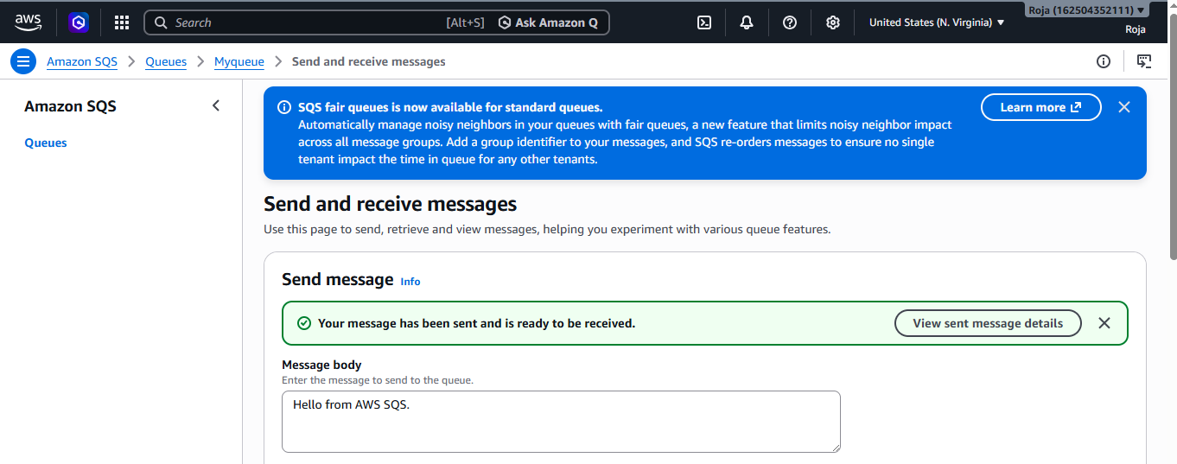

Step 4: Receive the Message
In the same Send and receive messages page, choose:
Poll for messages
You should see your message.
For example:
Message:
Hello from AWS SQS.

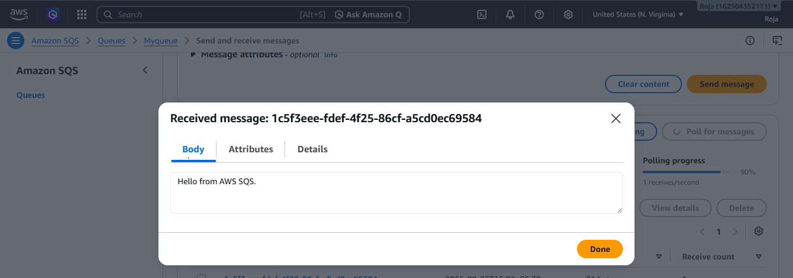

Deleted the message and confirmed it.
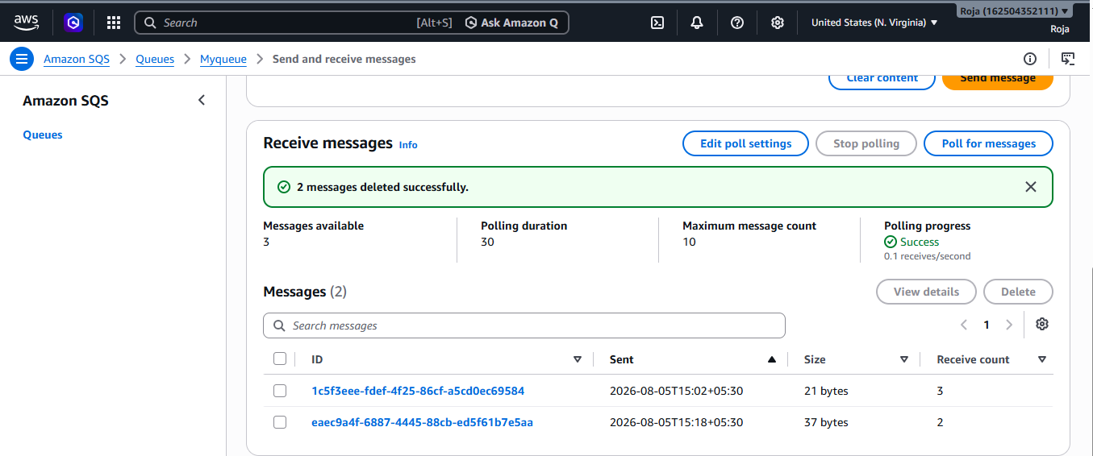

Step 5: Create a Dead-Letter Queue
Create another queue:
Myqueue2
Use:
Type: Standard
This will be your Dead-Letter Queue (DLQ).
Then go back to: Myqueue2
Find the Dead-letter queue configuration.
Configure:
Dead-letter queue:
Myqueue2
Maximum receives:
3
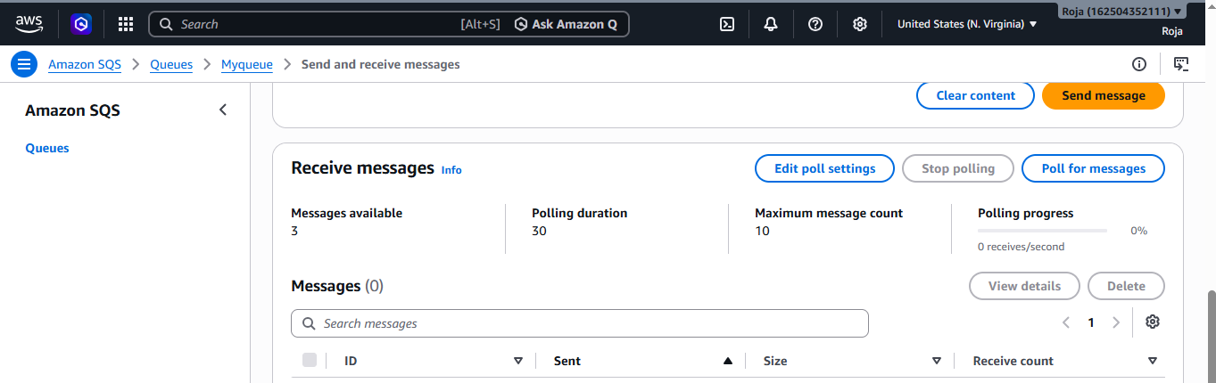

Step 6: Connect SQS with Lambda
Create a lambda function and trigger lambda
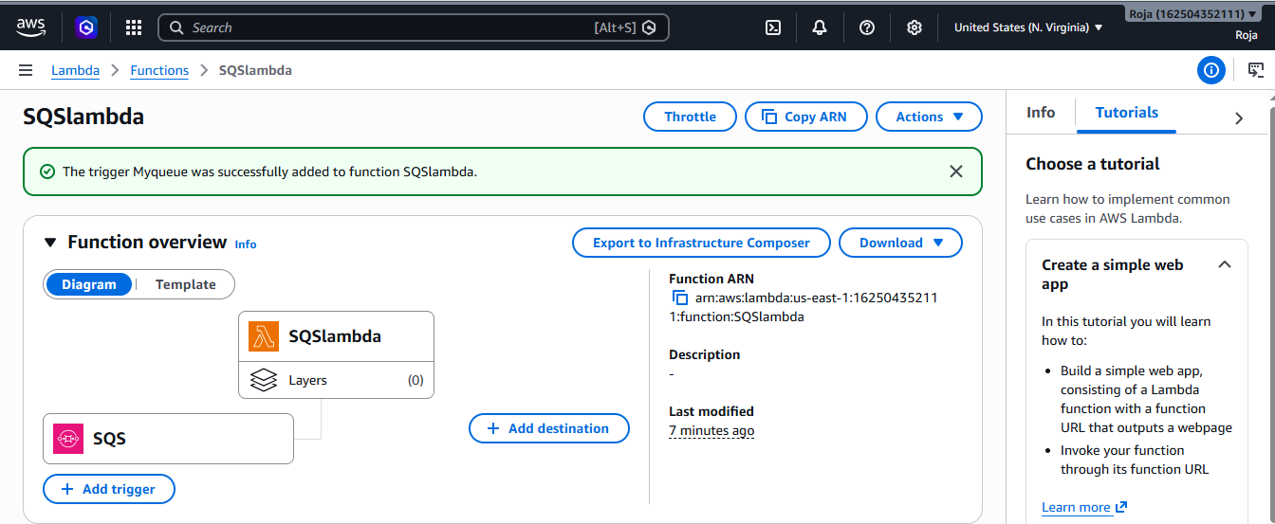
Step 7: Test SQS + Lambda
- Go to monitor option and click on cloud watch logs. It will redirect to cloudwatch logs
- Under log stream we can see logs, if we click on the log we can monitor our message.

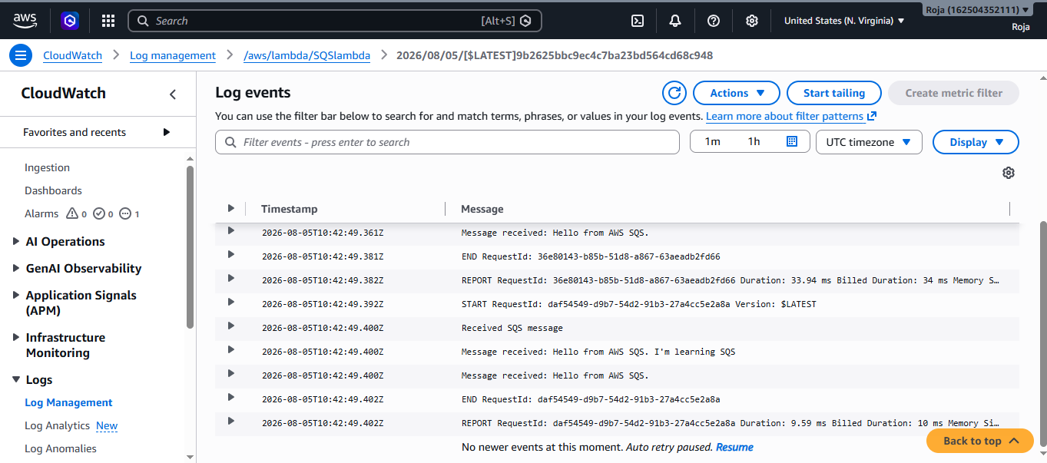

Amazon MQ
SQS is an AWS-native message queue, whereas Amazon MQ is a managed message broker for applications that use traditional messaging systems such as RabbitMQ or ActiveMQ.
To create an Amazon MQ for RabbitMQ broker and demonstrate basic message communication by creating a queue, publishing a message, and consuming the message.
Step 1: Open Amazon MQ
- Search for Amazon MQ.
- Open Amazon MQ.
- Select Brokers.
- Click Create broker.
Step 2: Select the Broker Engine
- Choose Broker engine : RabbitMQ
- Choose Deployment Mode: single-instance/single-broker deployment option
- Configure Broker Details: Broker name: devops-rabbitmq-broker
- Create RabbitMQ Login Credentials : Username: adminuser & Password: ********
- Configure Network Settings : Broker network access type: Public
- Review and create Broker.
The broker will initially show something similar to: Creation in progress status
Wait until the broker becomes: Running
This can take some time.

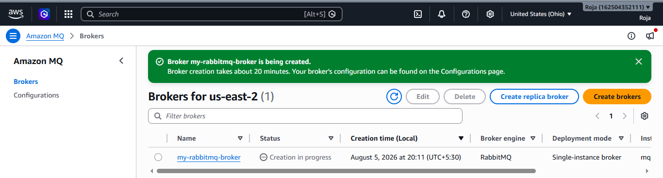
Status changed to running
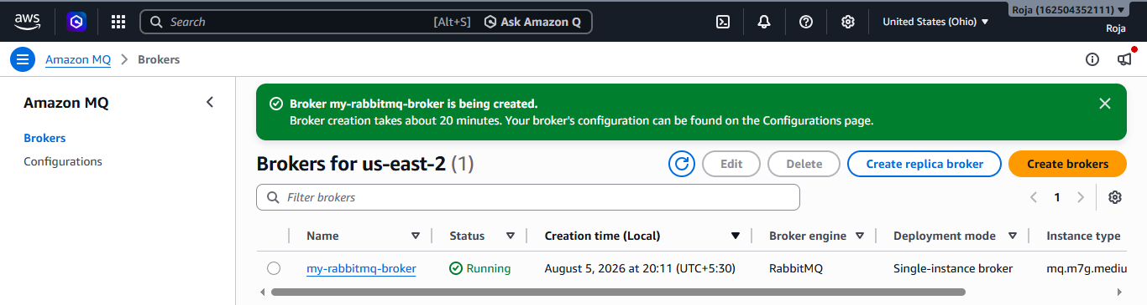
Step 3: Open the RabbitMQ Management Console
Once the broker is running:
- Open the broker details page.
- Look for the RabbitMQ web console / management console endpoint.
- Open the endpoint.
- Enter the username and password you created earlier.
You should see the RabbitMQ management interface.
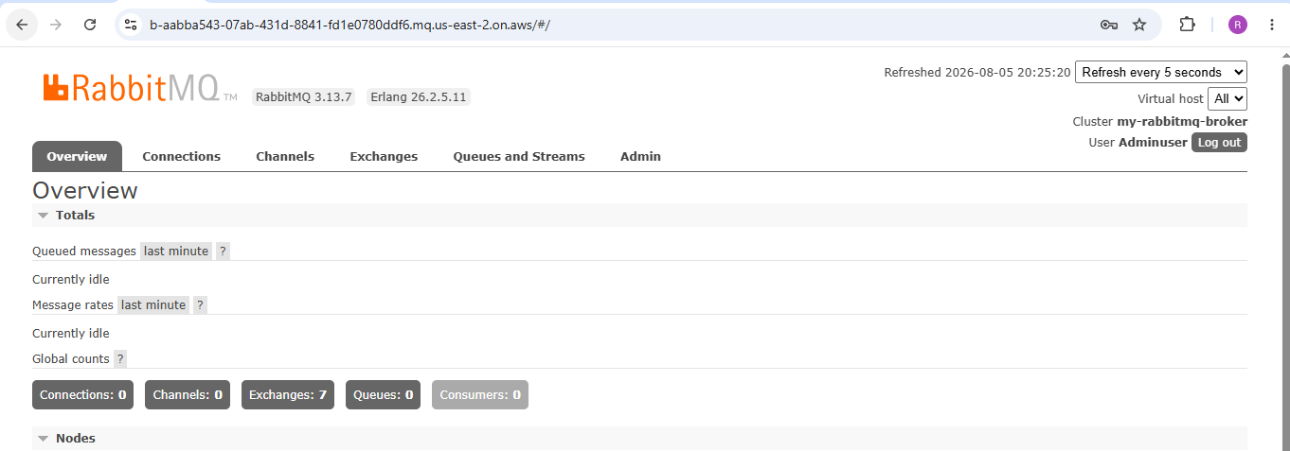
Step 4: Create a Queue
Inside RabbitMQ Management Console:
- Go to Queues and Streams.
- Select Add a new queue.
- Enter: Name: devops-demo-queue
- Use the default/basic settings for your first exercise.
- Click Add queue.
- You should now see: devops-demo-queue
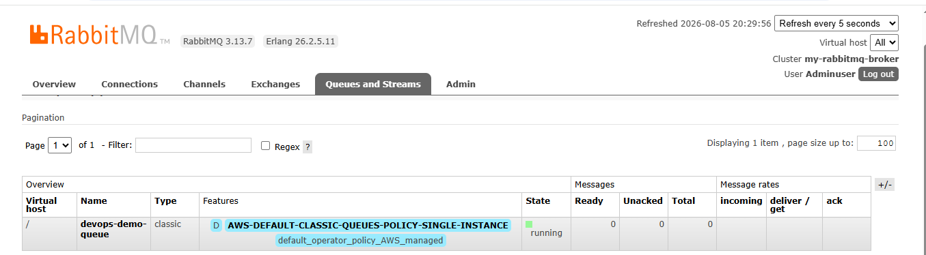
Step 5: Publish a Message
Open your queue.
Find the option for publishing a message.
Enter a test message such as:
Hello from Amazon MQ!
This is my first hands-on implementation.
Click Publish message
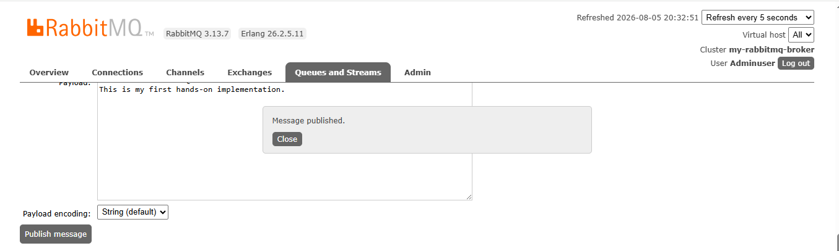

Step 6: Check the Queue
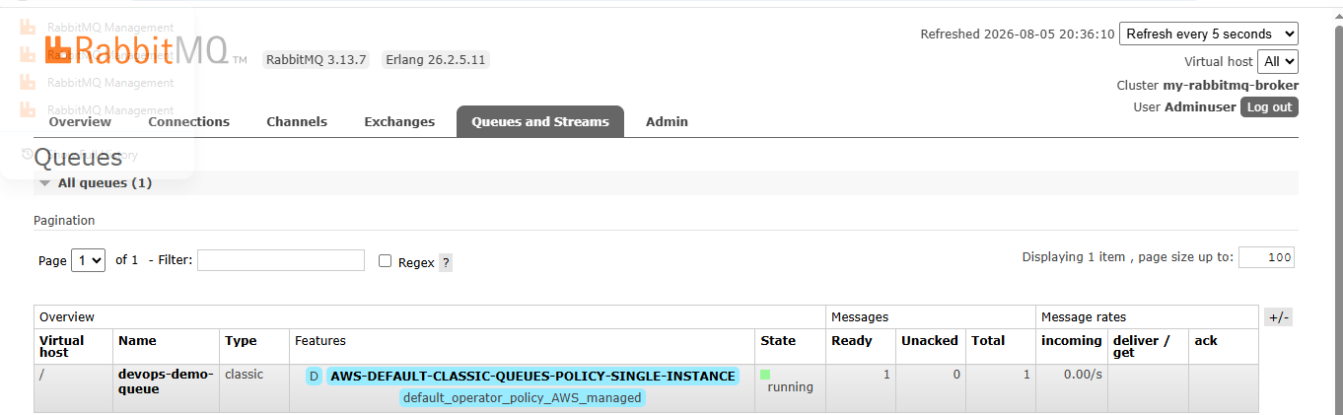

Step 7: Consume the Message
In the queue's management interface, use the Get messages function.
Select an appropriate message count and retrieve the message.
You should see:
Hello from Amazon MQ!
This is my first hands-on implementation.

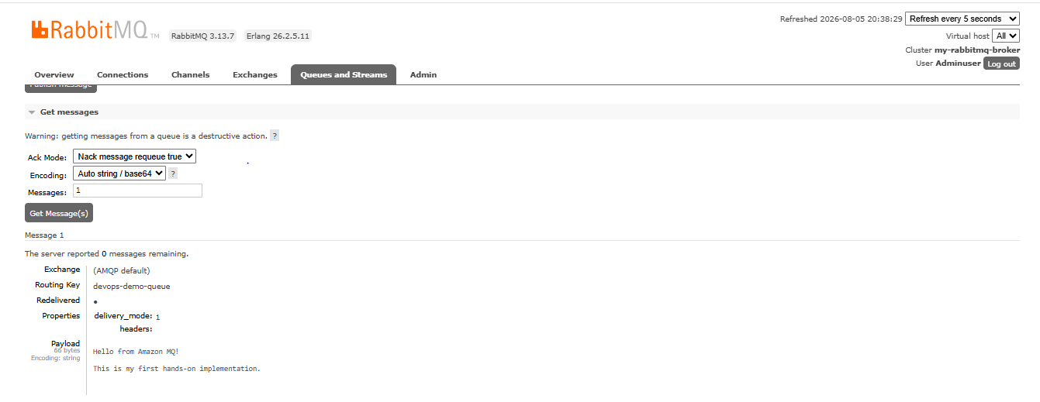
Step 8: Connect application to MQ
- Create a small Python application.
- Install the RabbitMQ Python client library.
- Get the Amazon MQ RabbitMQ connection details.
- Connect Python to Amazon MQ.
- Send a test message.
- Open RabbitMQ Management Console.
- Verify that the message arrived in devops-demo-queue.
Connect to EC2 server and create a file using vi editor to write a python script.
Then update packages.
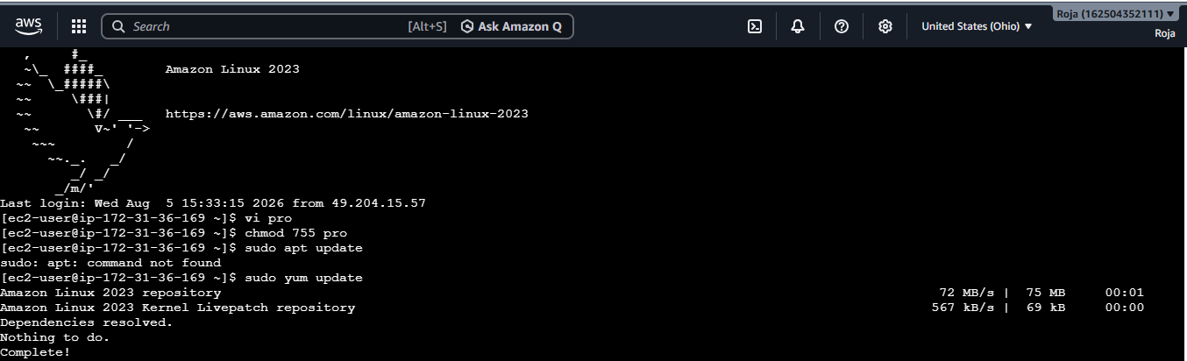
Install python
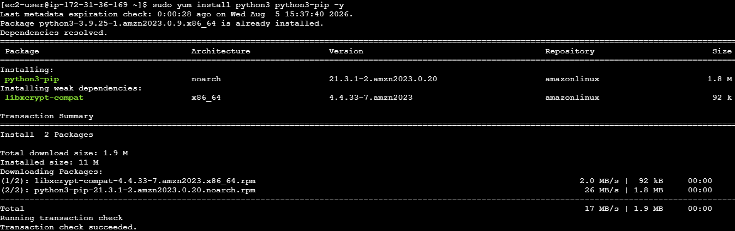
Python library called Pika, which is commonly used to communicate with RabbitMQ.
Check python version.
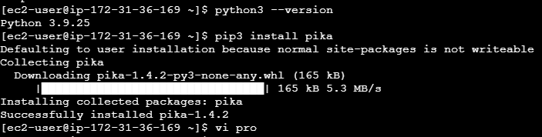
Run the script to see Message sent successfully!
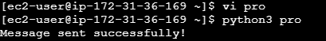
Step 9: Get Amazon MQ connection details
AWS Console → Amazon MQ → Brokers → Your RabbitMQ Broker
Find the connection details/endpoints.
You will need the RabbitMQ endpoint/hostname.
Which is in this format:
b-xxxxxxxxxxxxxxxx.mq.ap-south-1.amazonaws.com

Step 10: Update Security group

RabbitMQ uses TCP 5671 port so open All TCP to allow this port.

Step 11: Run Python application and verify in RabbitMQ Console.

Run the script to see Message sent successfully!
Go to RabbitMQ console
Queues and Streams → devops-demo-queue
You should see the message:
Hello from my Python application!

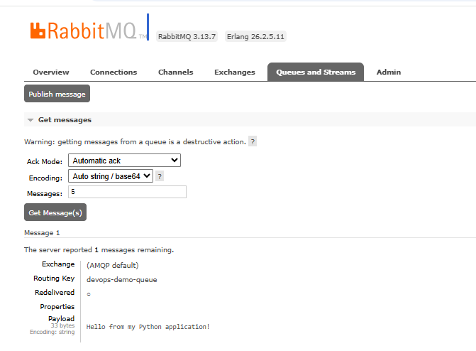

Amazon Secrets Manager
AWS Secrets Manager is a fully managed AWS service that helps you securely store, retrieve, and manage sensitive information, such as:
Step 1: Open AWS Secrets Manager
- Log in to the AWS Management Console.
- Search for Secrets Manager.
- Open AWS Secrets Manager.
- Click Store a new secret.
Step 2: Enter the details:
1. Choose Secret Type Credentials for Amazon RDS database or, if you're just learning without an RDS database: Other type of secret
2. Enter Secret Values: Add key-value pairs.
username = admin
password = MySecurePassword123
Click Next.
3. Configure Encryption
AWS automatically selects an AWS-managed KMS key.
Click next.
4. Name the Secret devops/database-credentials
Description: Stores database username and password for the demo application.
Click next.
5. Configure Rotation: Disable automatic rotation.
6. Review and Create: Review and click on create
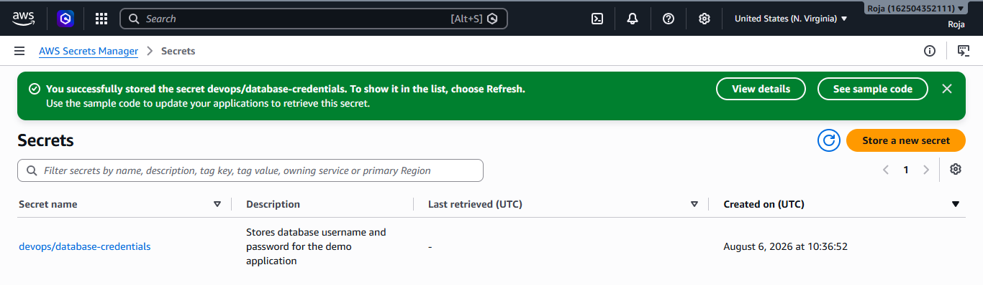
Step 3: Retrieve the Secret Using Python
Installed pip install boto3 python library and checked the python version
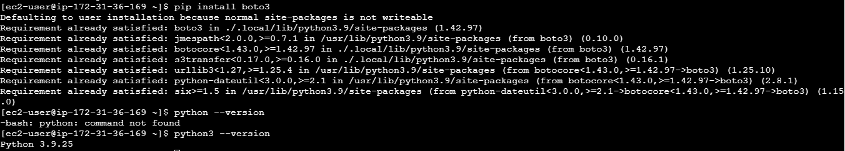
Create a file named secret and write a python script using vi editor
Run the python script to see username and password
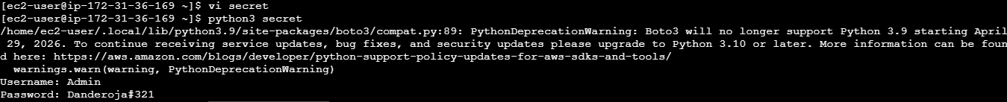

Step 4: Verify in CloudTrail
- Open CloudTrail.
- View Event History.
- Search for: GetSecretValue
You can verify when the secret was accessed and by whom.

